**PROGRAM 2**

**Consider the following database for a banking enterprise.**

**BRANCH (branch-name: String, branch-city: String, assets: real)**

**ACCOUNTS (accno: int, branch-name: String, balance: real)**

**DEPOSITOR (customer-name: String, customer-street: String, customer-city: String)**

**LOAN (loan-number: int, branch-name: String, amount: real)**

**BORROWER (customer-name: String, loan-number: int)**

1. **Create the above tables by properly specifying the primary keys and the foreign keys.**

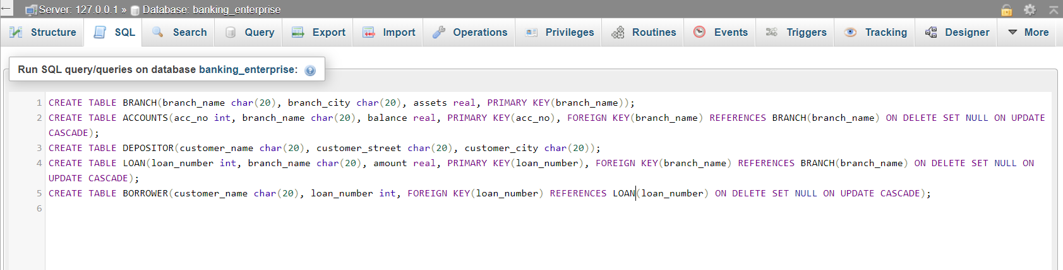

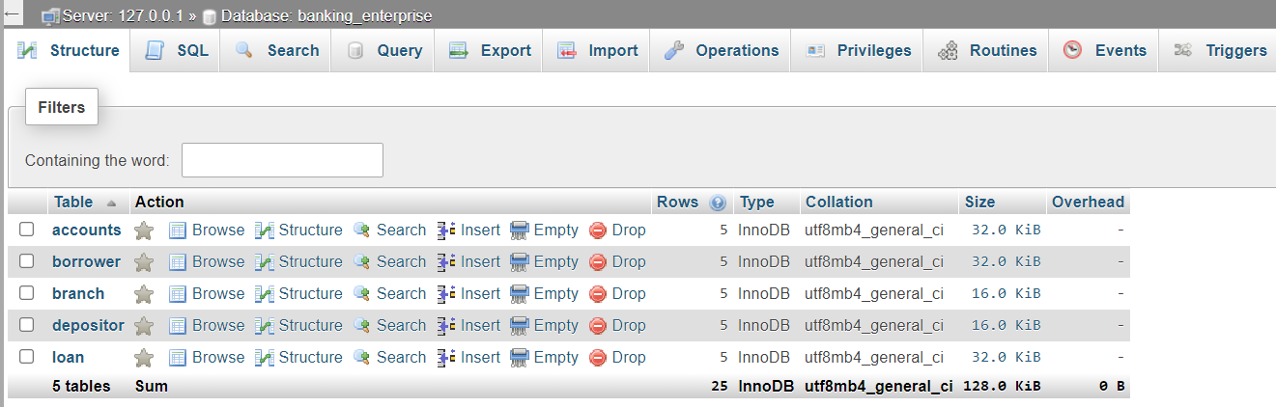

1. **Enter at least 5 tuples for each relation.**

**‘BRANCH’ table:**

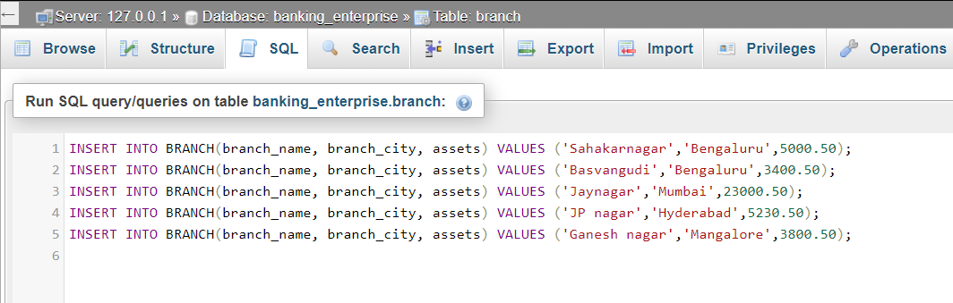

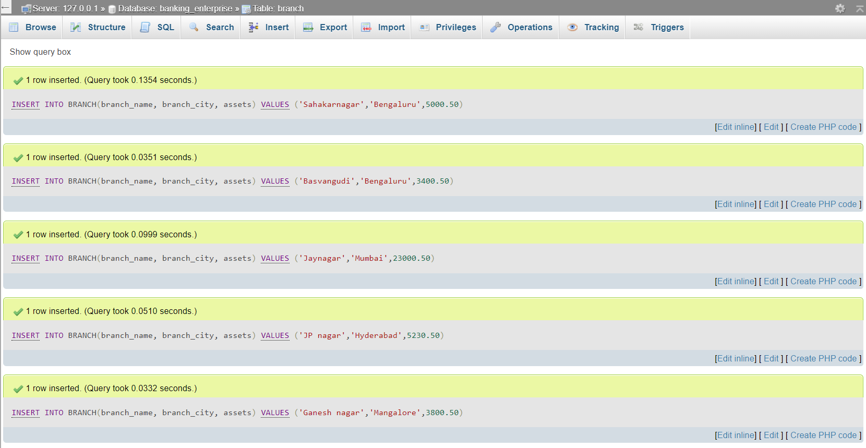

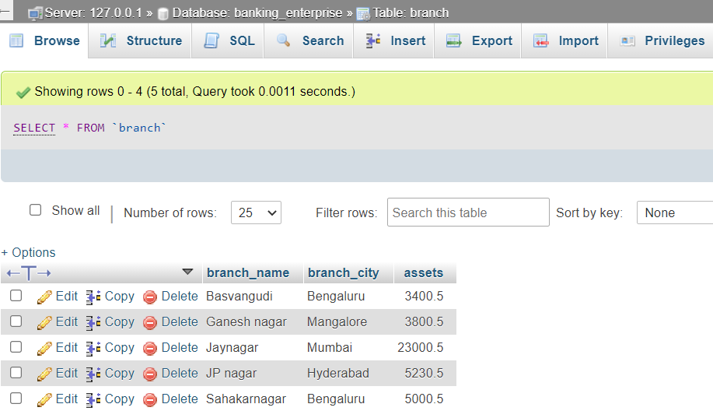

**‘ACCOUNTS’ table:**

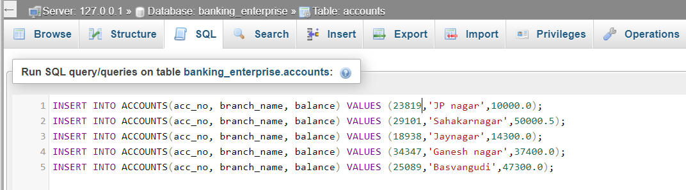

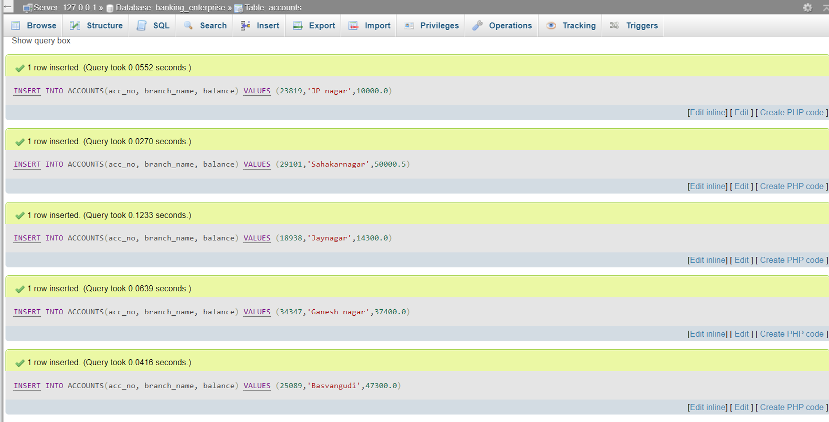

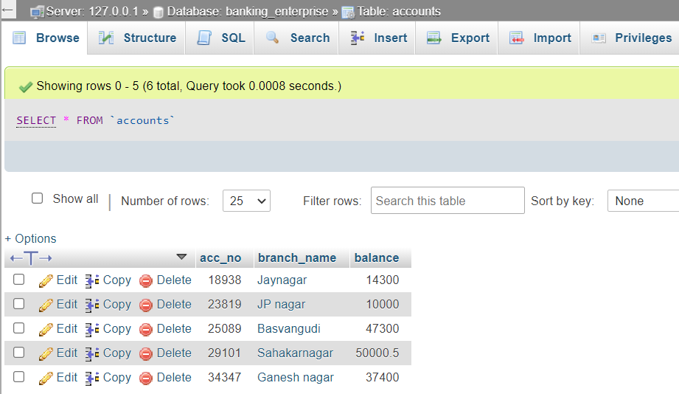

**‘DEPOSITOR’ table:**

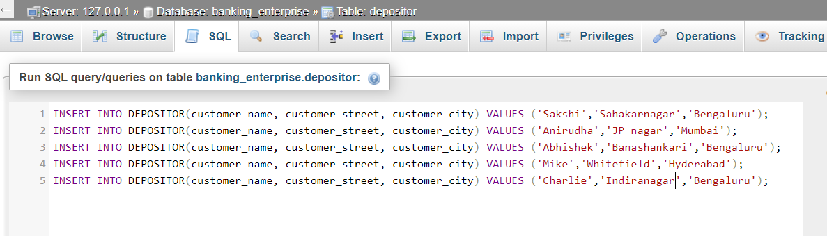

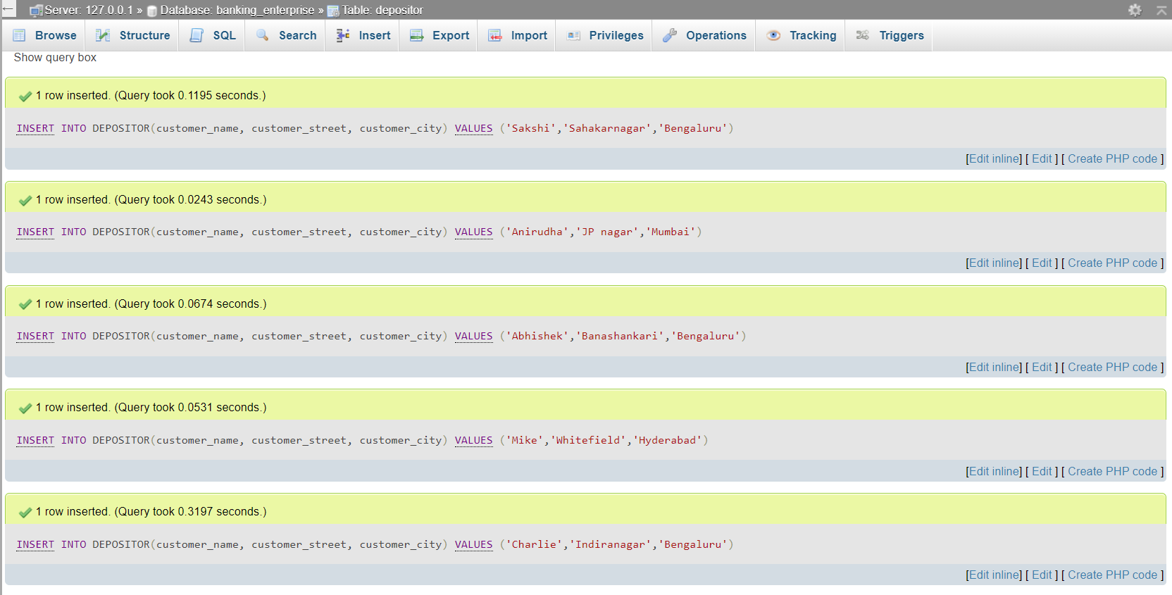

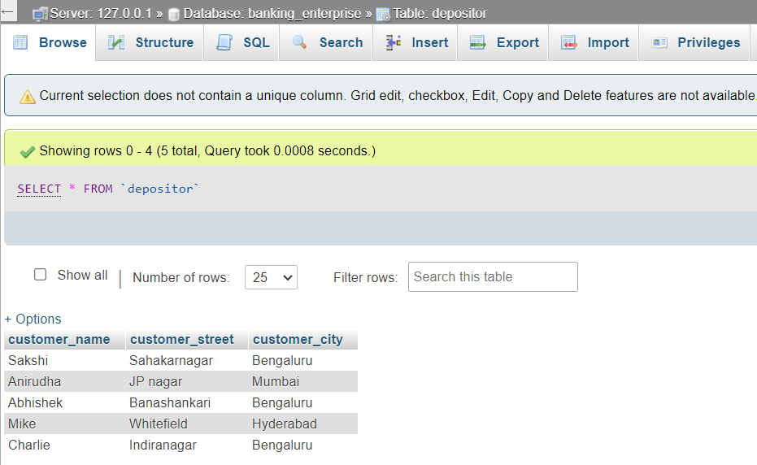

**‘LOAN’ table:**

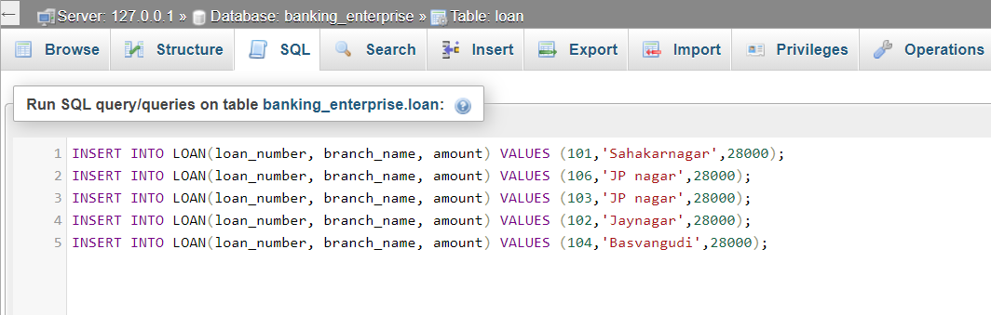

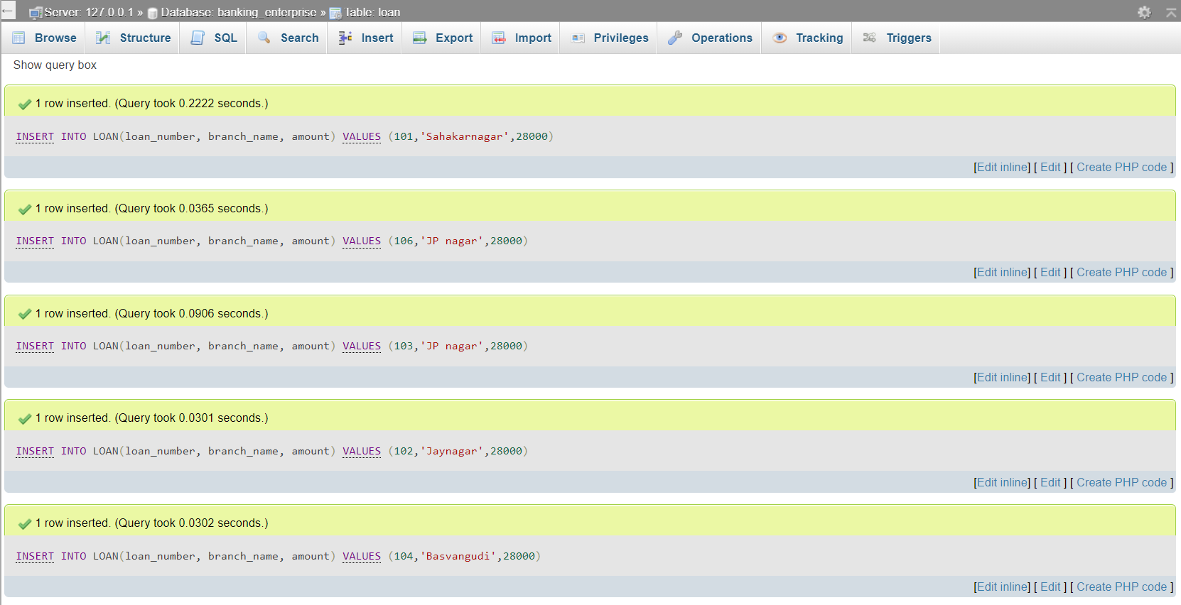

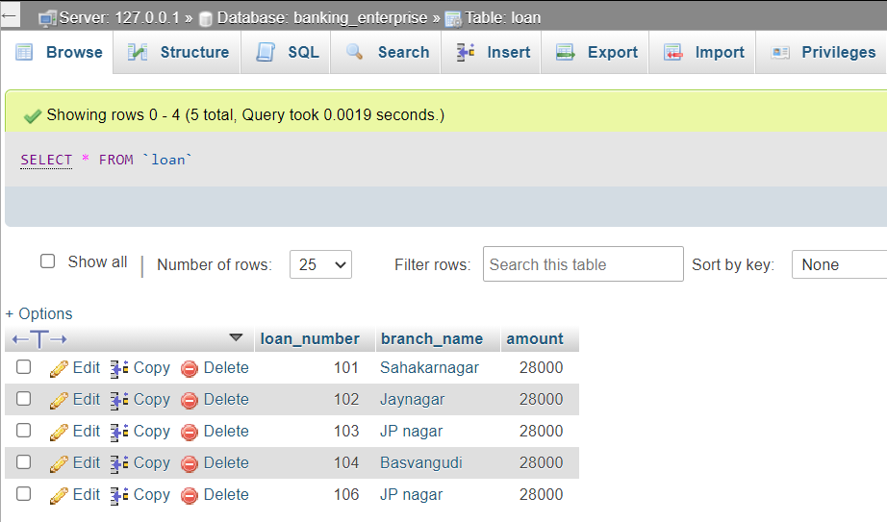

**‘BORROWER’ table:**

